

TOSHKENT SHAHRIDAGI INHA UNIVERSITETI

INHA UNIVERSITY IN TASHKENT

INTERNET PROGRAMMING

RESTAURANT

GROUP PROJECT



**Team Members:**

* Makhamadaliev Ibrokhimjon (U1810048) – section 004
* Rajabov Javokhir (U1810075) – section 003
* Akhmedov Fazliddin (U1810087) – section 003
* Kuziboev Anvar (U1810269) – section 003

**Link to Our GitHub repo: https://github.com/iuthub/ip-group-project-founders**

**Link to Our Web Site: http://protected-lake-57391.herokuapp.com**

## Project Overview

### Brief description of business and roles

### Functionality of website and its construction

### Contributions

**Brief description of website and its construction**

Benefits for costumers of website

They can reserve a table any time

* They can know cost of foods beforehand
* They can reserve a table any time
* They will not waste their valuable time on waiting dispatch to answer
* They will know what to expect from menu of restaurant

Benefits for restaurant of website Controlling and monitoring business

* Brand recognition
* Controlling and monitoring business
* Automation of a business
* Growth of client base

Besides this, clients can choose their orders from the menu beforehand and when they come to the restaurant they just show the QR code generated by the site. In the restaurant workers scan the QR code and accept the order immediately. We believe that it helps to process clients orders faster.

Login details of admin:

Email: [admin@admin.com](mailto:admin@admin.com)

Password: admin

**Functionality of website and its workflow construction**

**Home page**

**Home is the same for costumer and admin too.**

**In beginning of the home page, there are 3 carousel pages.**

**In the 1st one, clicked “More About Us” button goes to About page.**

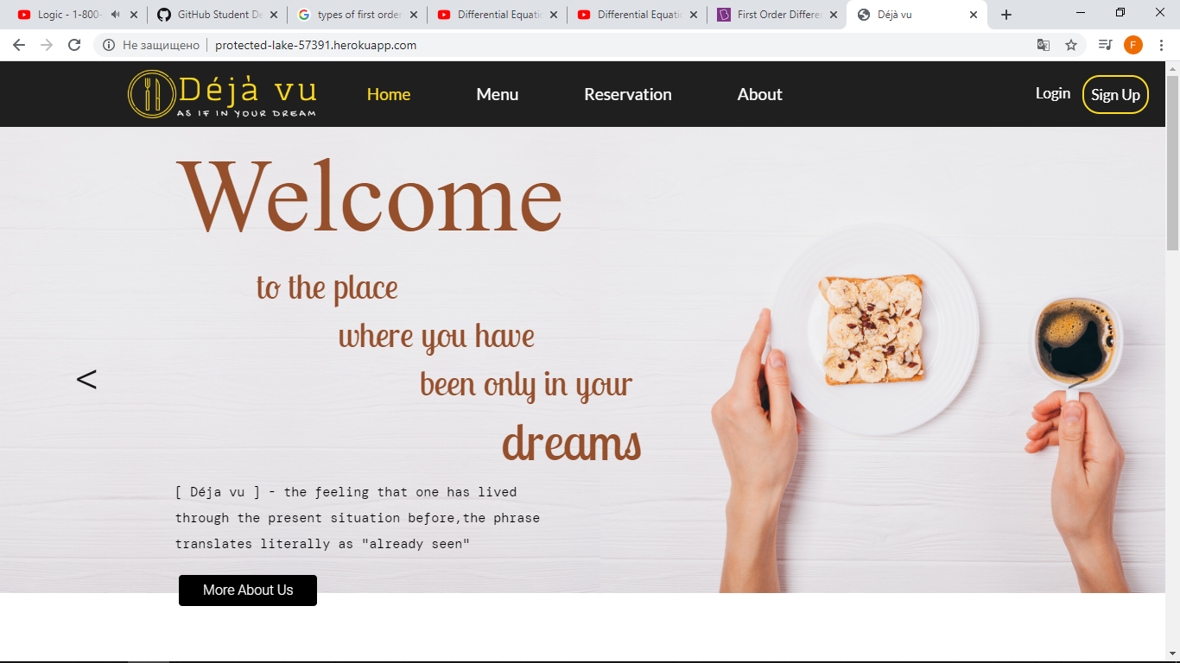

**In the 2nd one, clicked “Try It Now” leads to Menu page**

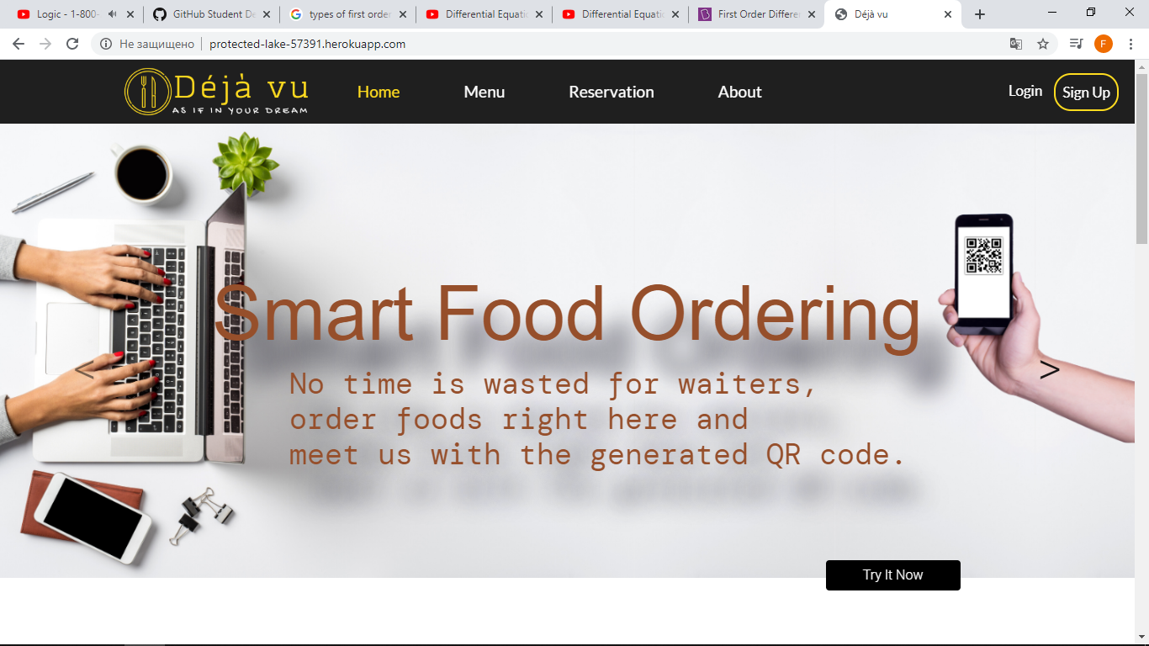

**In the 3rd one, clicked “ Sign Up Now” brings to the Register page.**

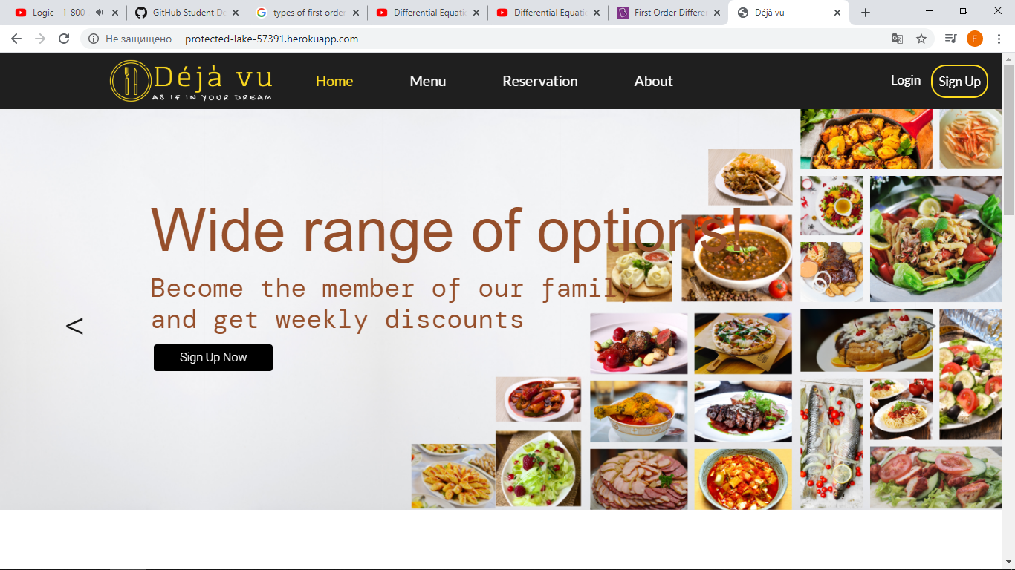

**Menu page**

**In the Menu pages, there are 2 pages. One is default and 2nd is for admin. For admin page, it needs to be logged as an admin.**

**Here are screenshots of admin where foods can be added, edited and deleted.**

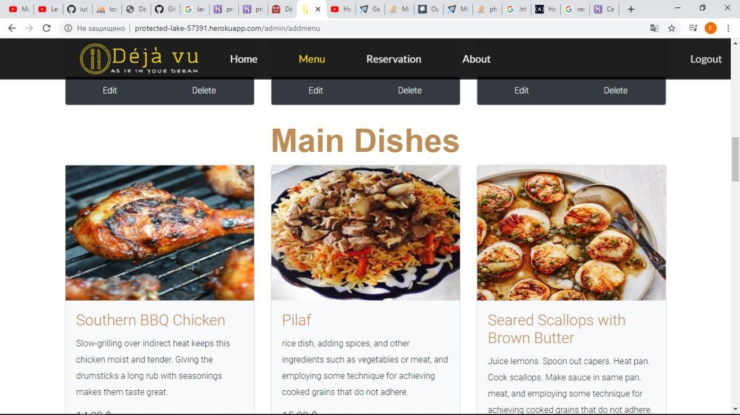

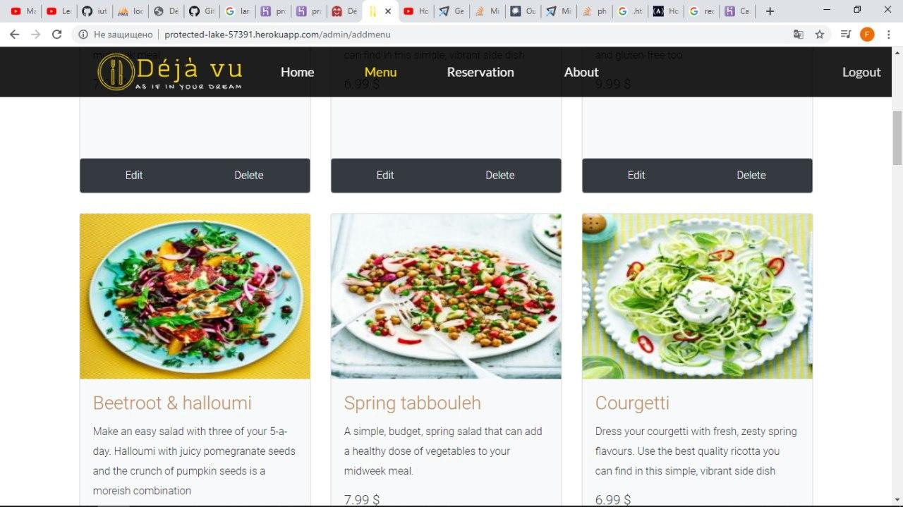

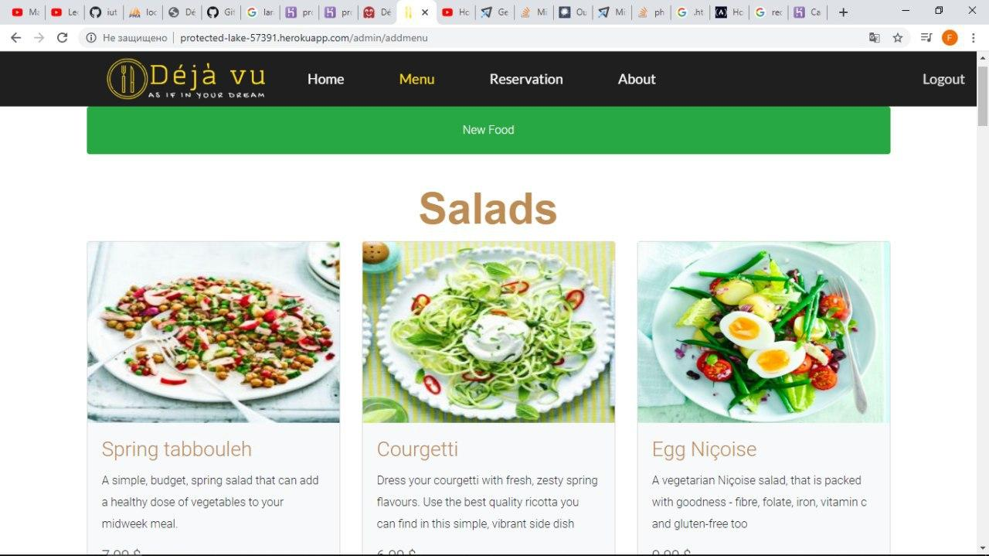

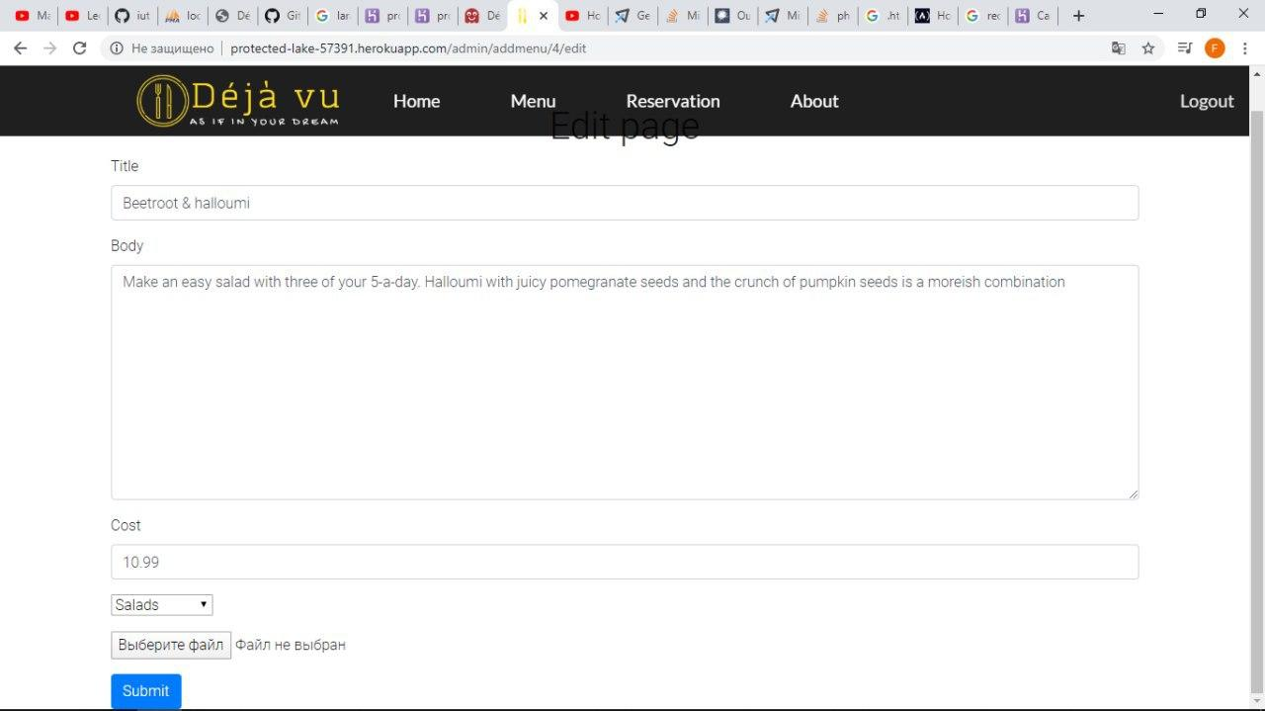

**And here Menu page for customers.**

**User can choose what to order and show the quantity**

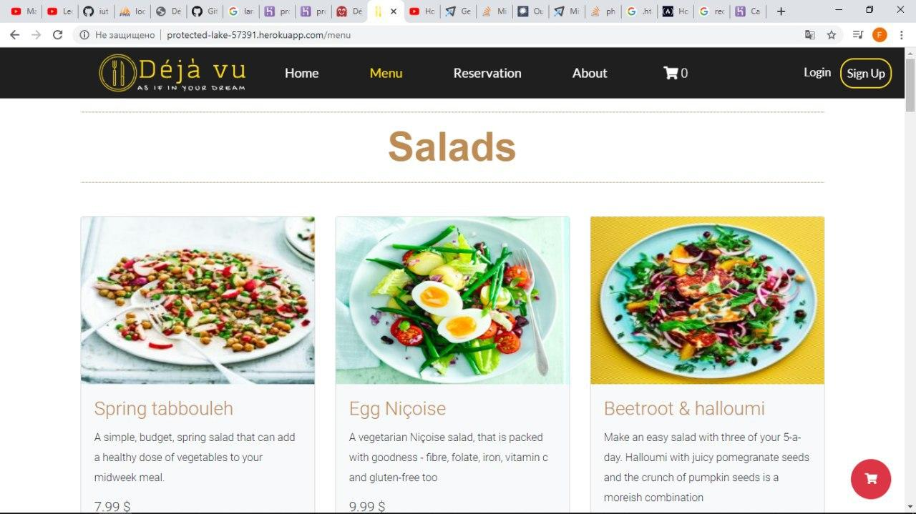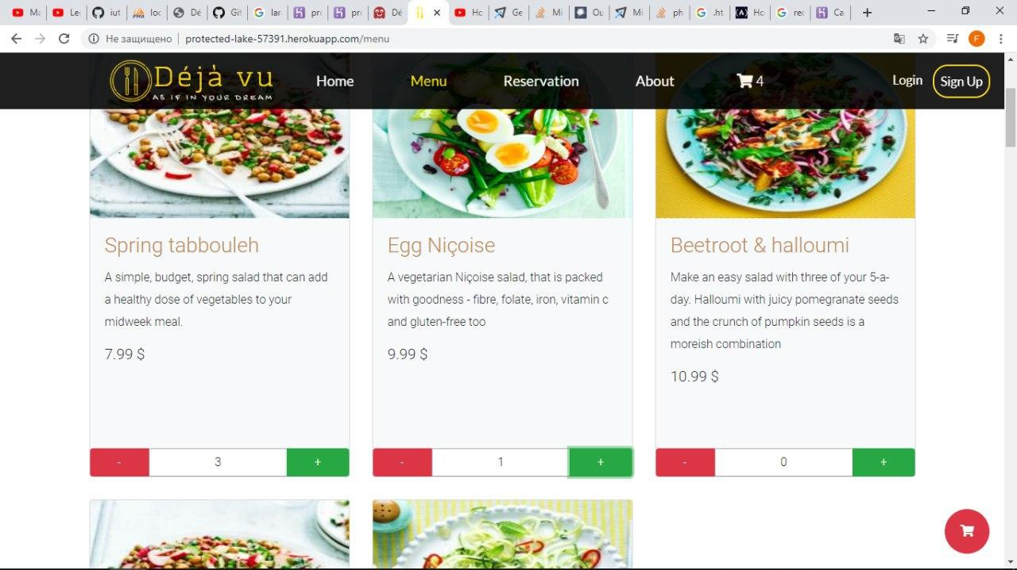

**When the user clicks the cart icon either on the navbar or on the top bottom left corner their cart is shown with the foods that they’ve chosen**

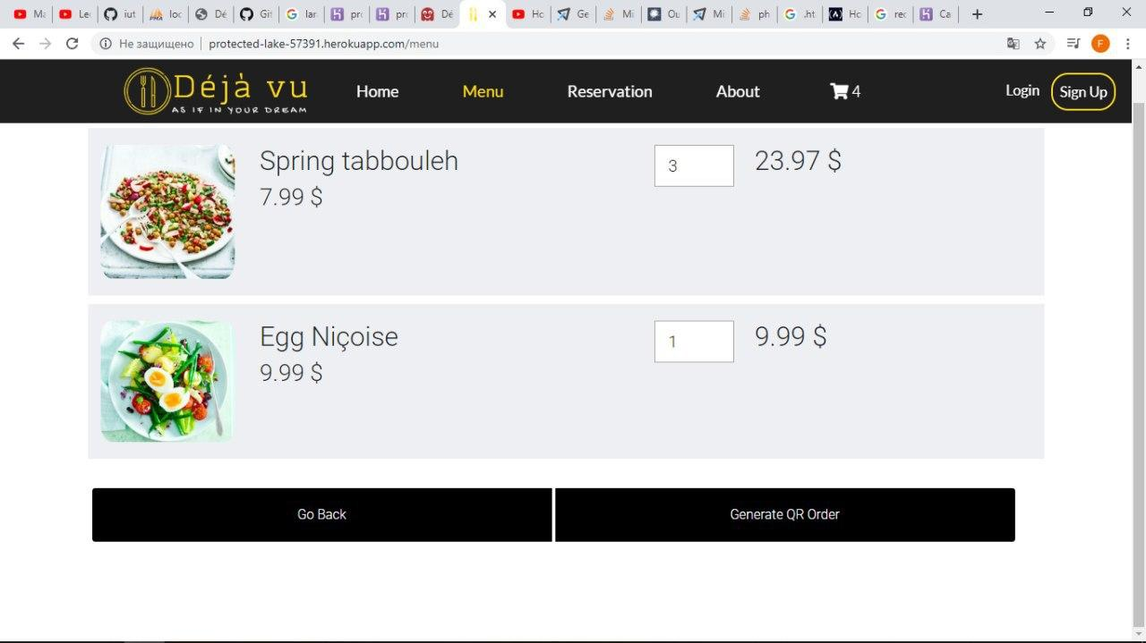

After that the user can generate QR code which can be scanned by the worker to process the order immediately. This means that a person can choose what to eat on the way to the restaurant and after one quick scan their order is accepted

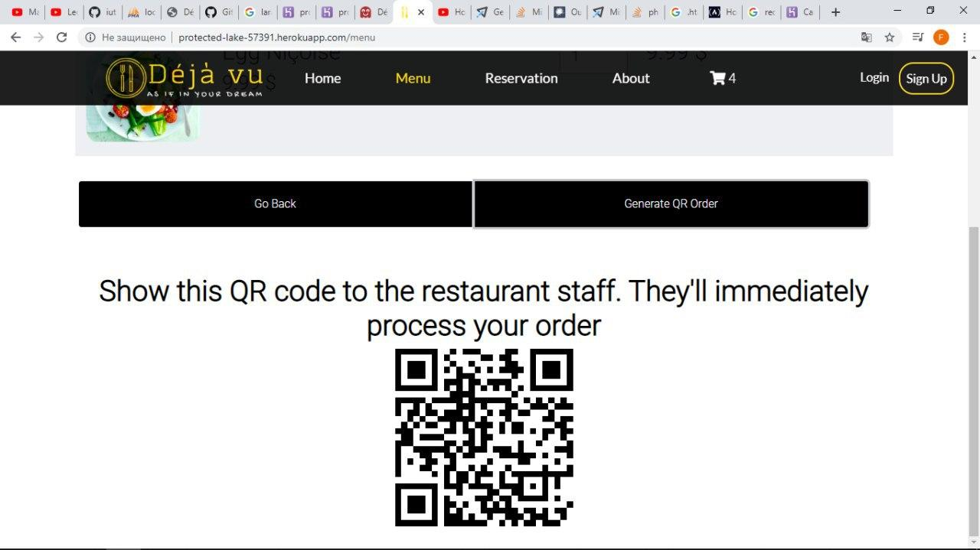

**About page**

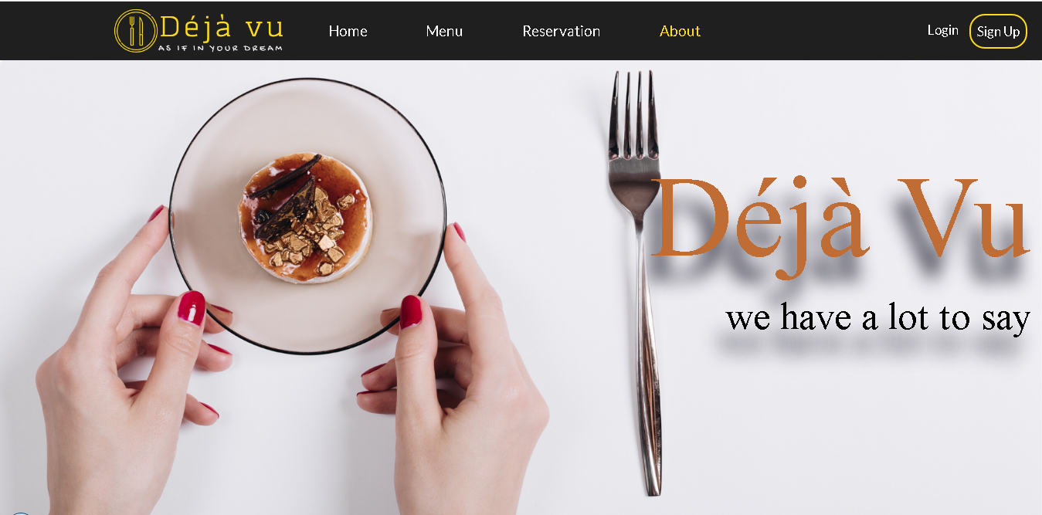

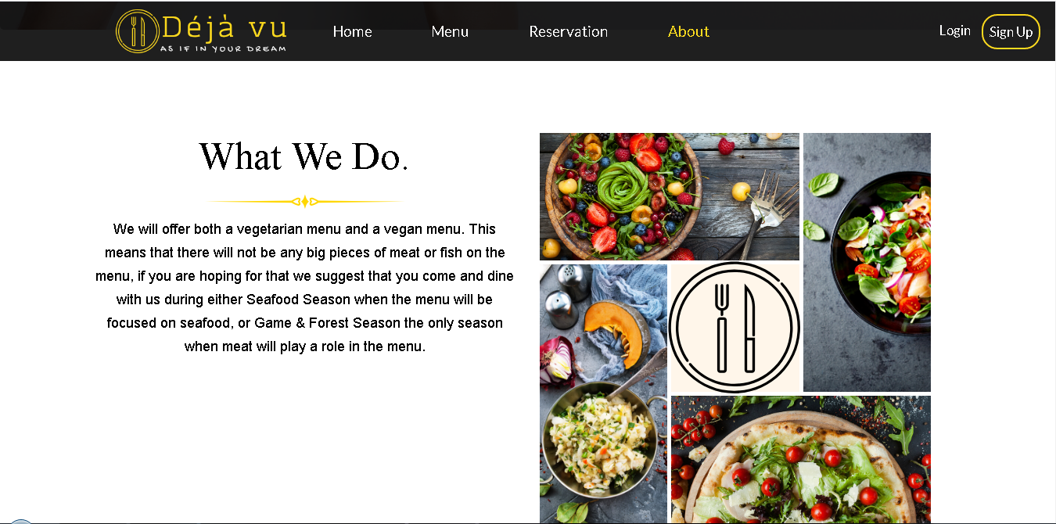

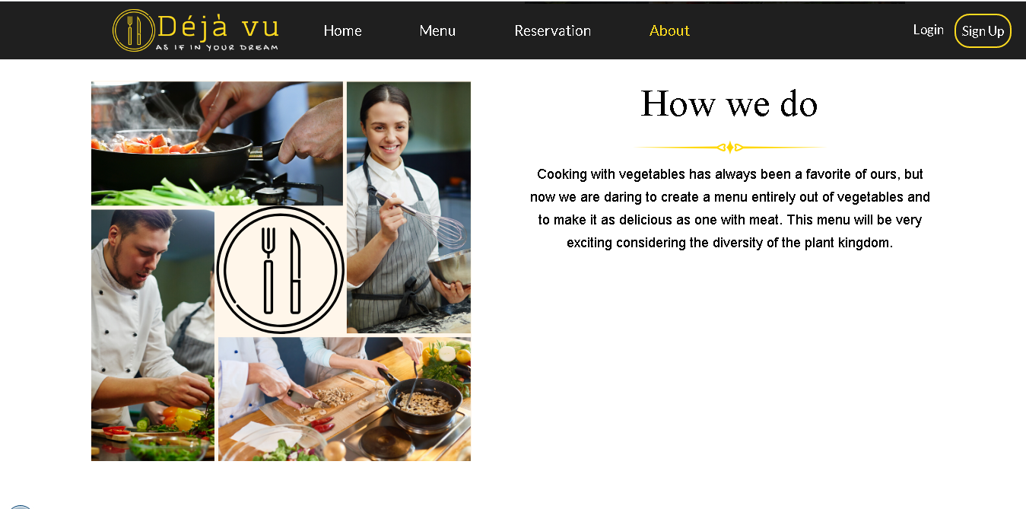

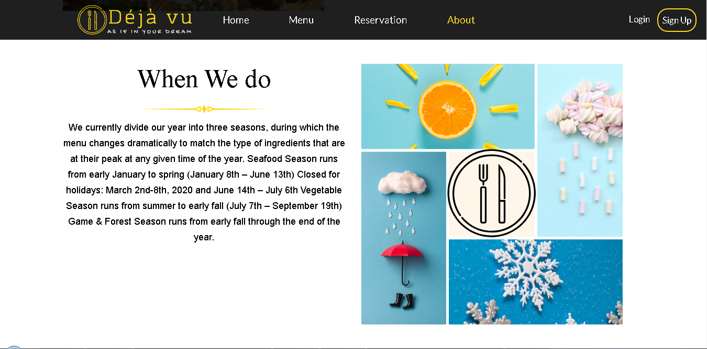

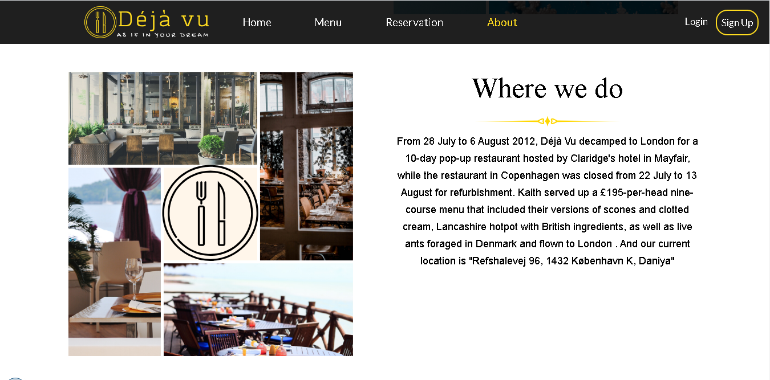

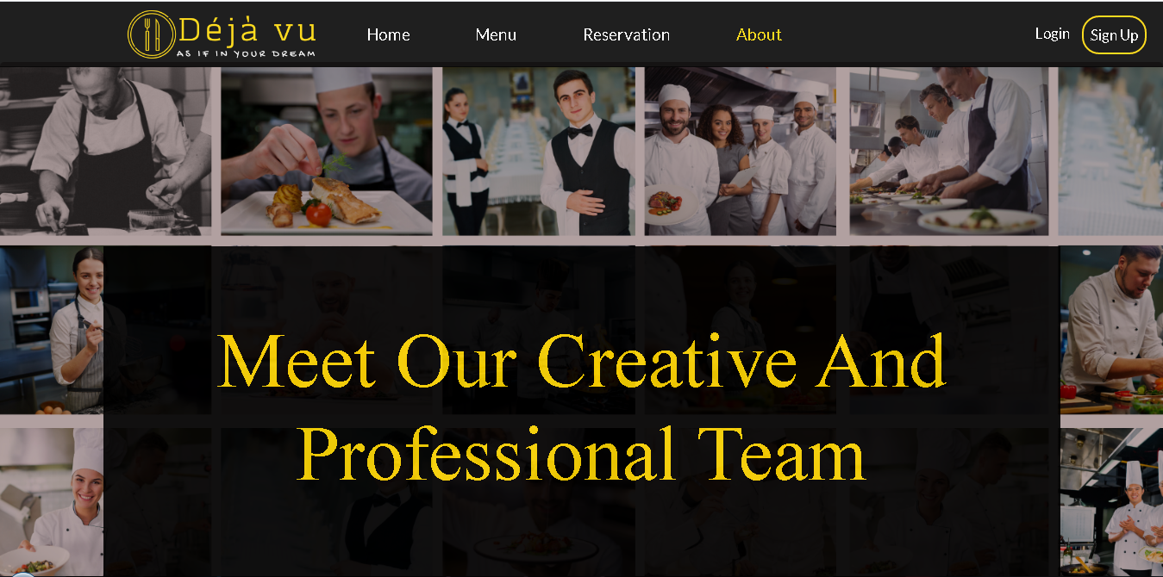

**Login Page**

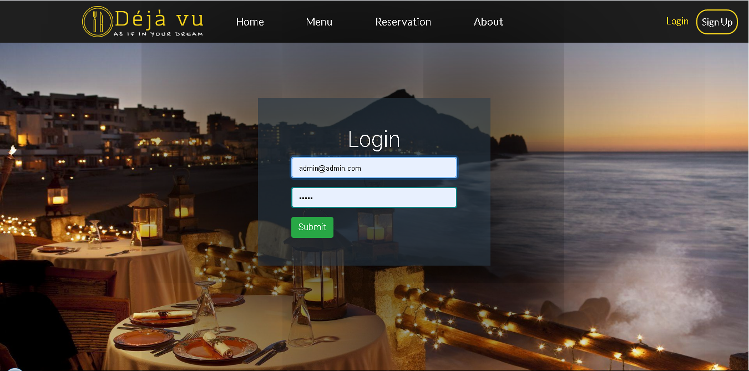

**Sign Up page**

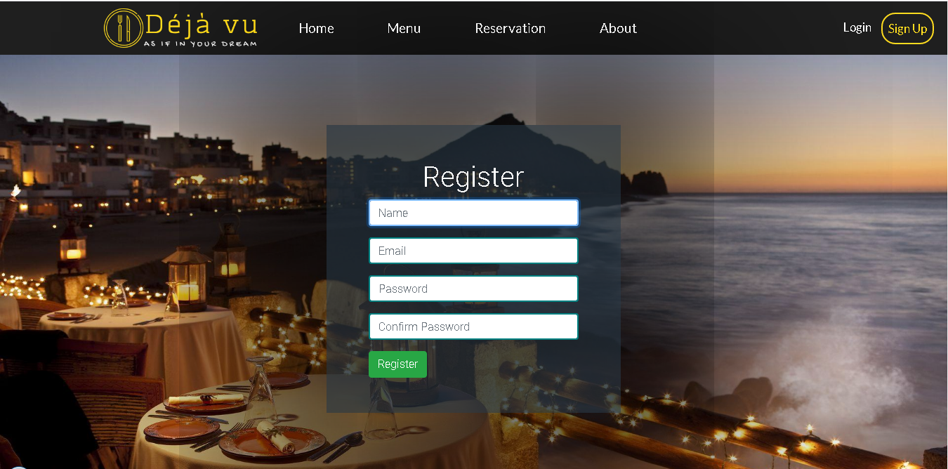

## Contributions

We have shared tasks as written below:

1. Makhamadaliev Ibrokhimjon- Partly Menu and Home page. Report of the Project
2. Rajabov Javokhir - Admin-side Back-end
3. Akhmedov Fazliddin – Front-end and Javascript functionality of menu page for admins and guests, backend of reservation, reservation page of admin
4. Kuziboev Anvar – Front-end of login and singup and reservation